Issue#1 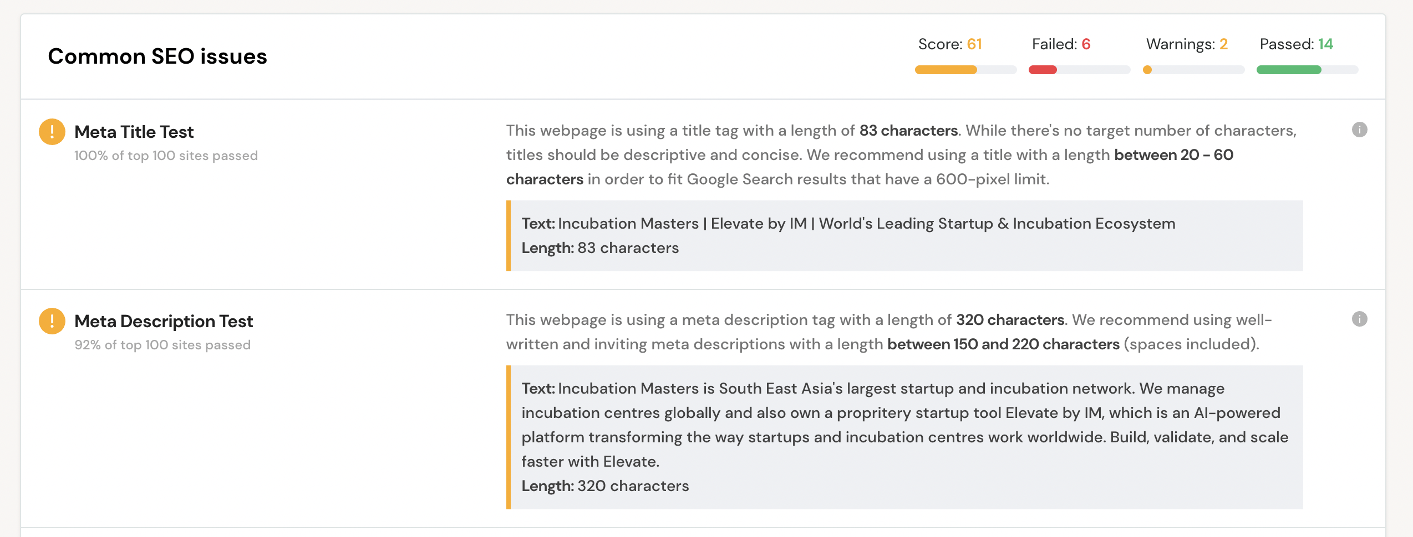

Issue#2

Issue#3

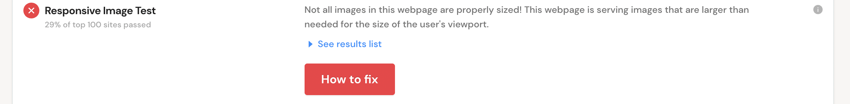

Issue#4

Issue#5

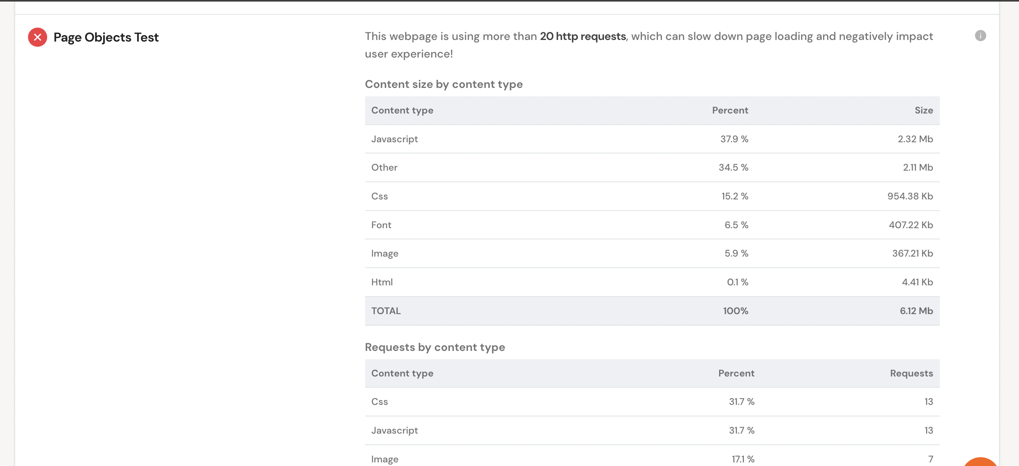

Issue#6

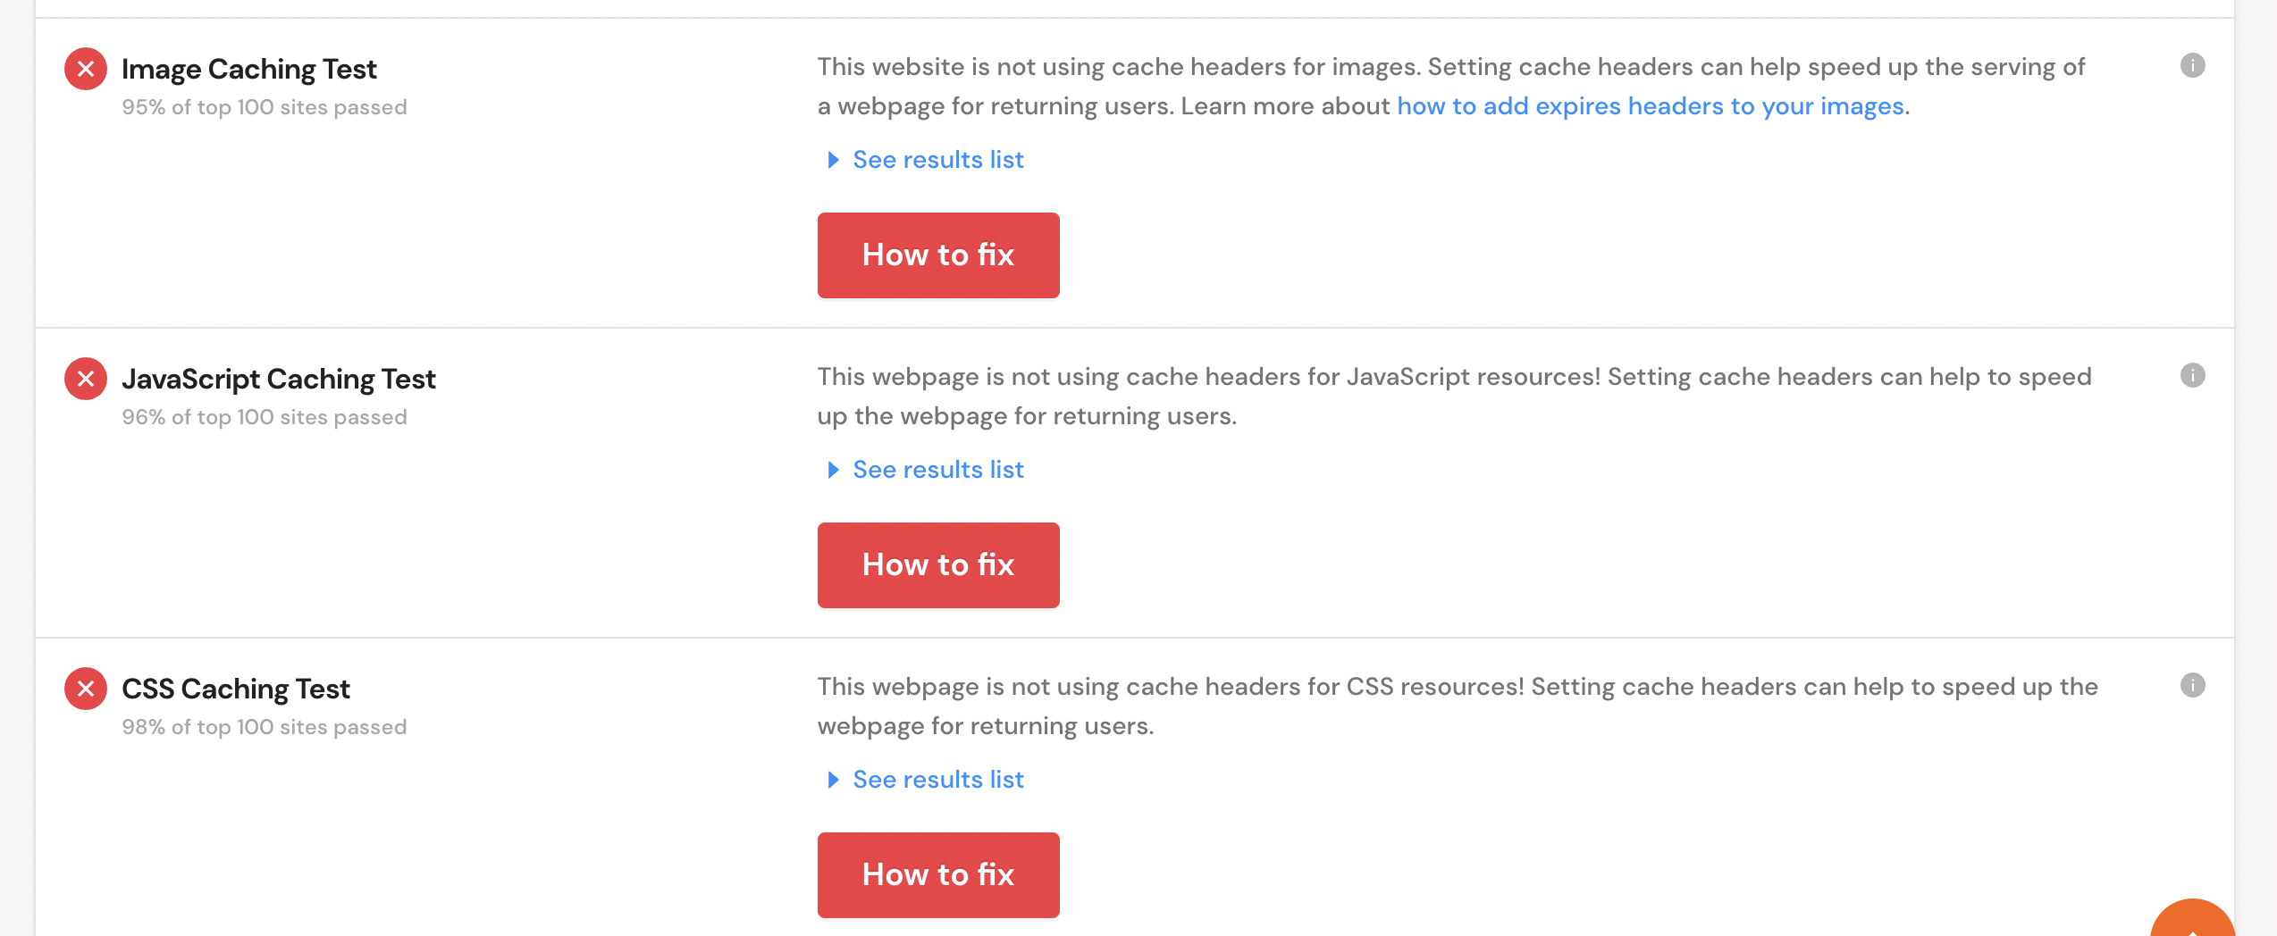

Issue#7

Issue#8

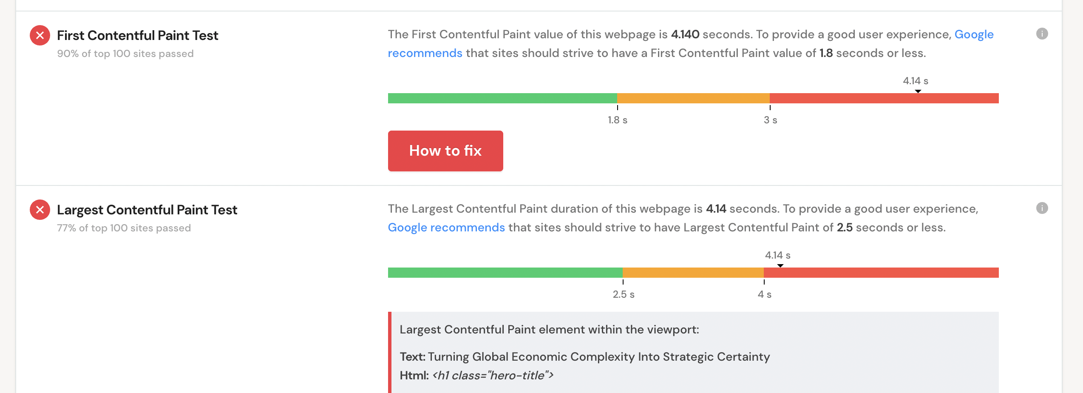

Issue#9

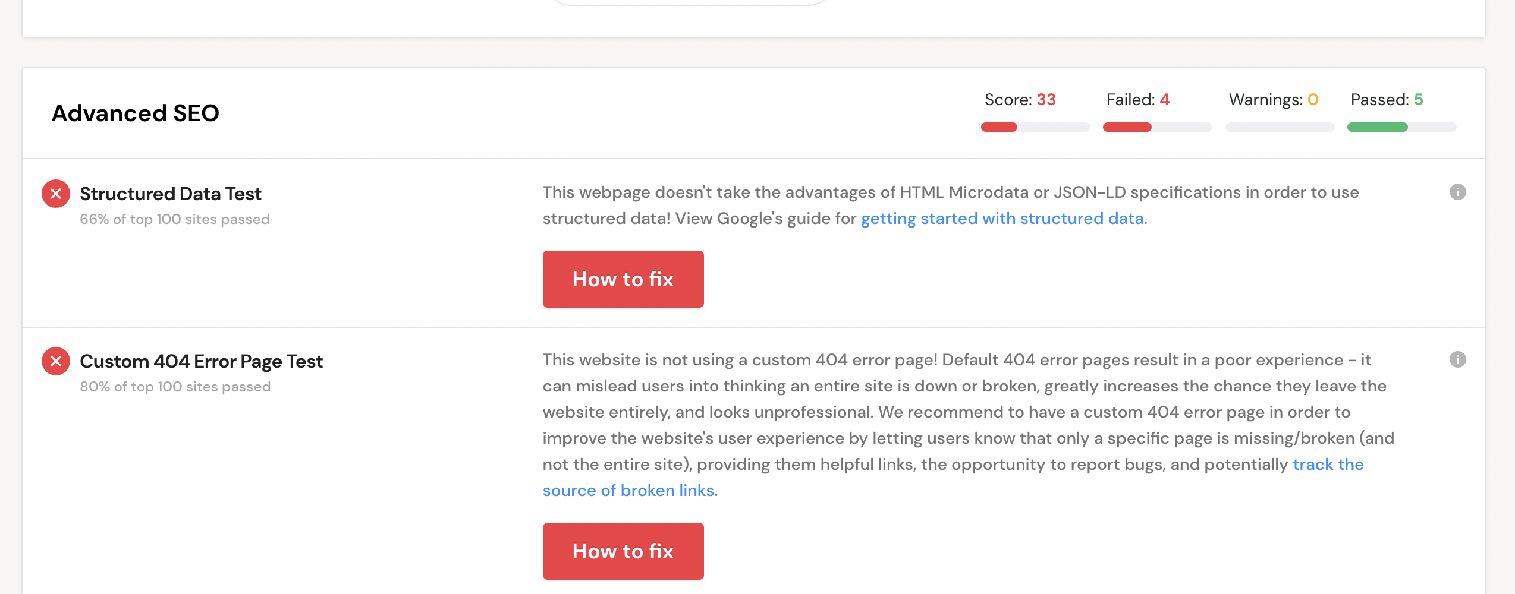

Issue#10